

STOCK MANAGEMENT

RECOMMENDATION ENGINE

**Product Recommendation**

Build a recommendation engine

The Challenge

Recommender systems are one of the most prominent examples of machine learning nowadays. They determine what shows up in your Facebook news feed, in what order products appear on Amazon, what videos are suggested in your Netflix account, as well as countless other examples. Recommendation Systems are used in a variety of areas including movies, music, news, books, research articles, search queries, social tags, and products in general.

The goal of a recommendation engine is to recommend relevant items to a user, based on historical data.

The customer we are working with, is a multi-national company that works on the health sector. They want to predict what products their customers shall need the most, based on their past purchases but also on other variables that could be interesting (this would be part of your research).

Data

Given the data restrictions from our customer, we are not allowed to share internal data. We have created a fictional dataset that tries to recreate the real scenario.

The dataset consists in two different files:

* stock.csv - transactional information about sales of products:
  + country_code – Code of the country
  + cac – customer
  + product_code – product sold
  + month_code – year and month of the sale
  + currency_code - currency
  + invoiced_sales - sales
  + volume_primary_units – number of sold units
  + inventory_cost – cost of the product for the company (unitary cost multiplied by volume)
* product_master.csv – To complement the file above with more details about the product.
  + bravo_ww_fran_name – company designation for the global group
  + bravo_fran_name – company designation for a region of the group
  + bravo_sub_fran_name – company area
  + bravo_major_name – product family
  + bravo_minor_name – product sub-family
  + product_code – product code

This attributes above represent the product hierarchy (see image below).

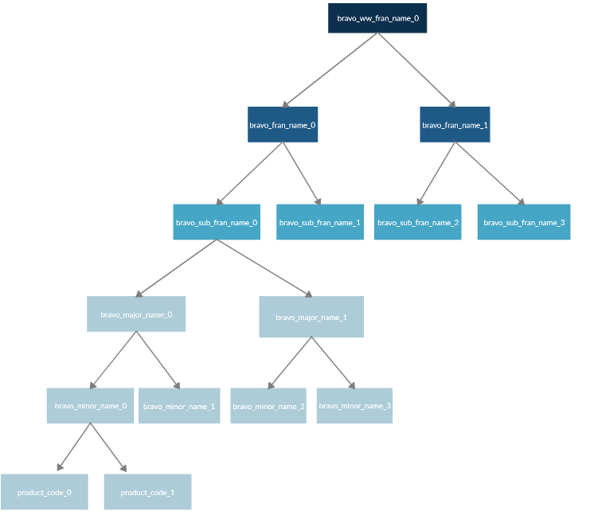

Note: you will need to join this table with the table before using the attribute product_code

Technologies

No limitations. Can be R, Python for data understanding, data preparation, feature engineering and modelling.

Azure Machine Learning Studio, with its easier drag and drop interface for the construction of the recommendation engine, could be also use. You need to use your Microsoft account (or create one), the AML studio is free until a certain amount of data.